How to Dry Brush Your Skin
Your skin is an organ of elimination, just like your kidneys, liver, and colon. Dry brushing, known to increase blood circulation and stimulates lymphatic drainage, which are
important components of detoxification of the body. Dry brushing also exfoliates the skin’s outer layer and stimulates the sweat and oil glands, providing more moisture for the skin.

Instructions for dry brushing:
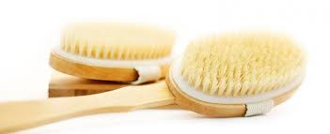
- Dry brush first thing in the morning before you shower. Use a natural bristled brush
( Available i.e in Chemist Warehouse).

- Start with the soles of your feet using swift upward strokes. Start with light pressure and then move on to firmer strokes.

- Brush from the feet up the legs, working toward your heart.

- Next, move to your hands and work up your arms toward your heart in the same manner.

- Brush your back, as best you can, using a long-handled brush if you have one.

- Work on your abdomen, moving in a clockwise direction to follow the movement of the colon, then do the chest and neck.

- Using circular motions, rub the scalp vigorously. Avoid dry brushing your face as facial skin is too sensitive.

Brush for about 3 to 5 minutes until your skin is slightly tingly. Shower after you dry brush to wash off the dead skin. Remember to periodically wash your brush with warm soap and water.

